Introduction
I will be very happy to discuss a detailed package and a detailed quote with you using these three main packages below as the starting point in each case and then to build a specifically tailored programme to meet your requirements. Please note that I am also very happy to cover the Civil Partnership ceremony as your Photographer. All packages will include a detailed planning session(s), as standard, to ensure that we cover all of your requirements and map out the key elements of the Big Day. The planning session(s) is a free consultation and this will allow me to make sure that the arrangements work for you and that we capture every one of the moments and images that you want during your very special day. I would prefer that we hold this initial planning session with both the prospective Bride & Groom together or in the case of a Civil Ceremony with both Partners together and that the session be held in your locale and to be at least 4 - 6 weeks prior to your very special day to allow for any fine tuning.
Some images below illustrate albums and additional products that we can provide using our partner/suppliers for items like PhotoBooks, Photograph Albums, Prints on various material like canvas, block mounted images, acrylic or metallic finish. Quotations for these additional items can be provided upon request.
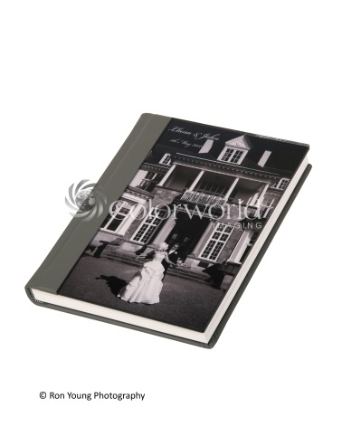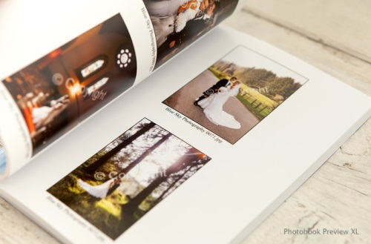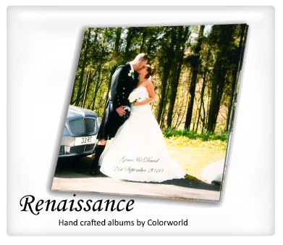
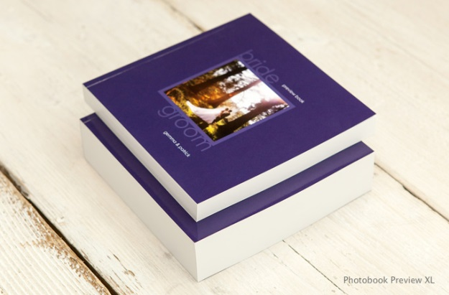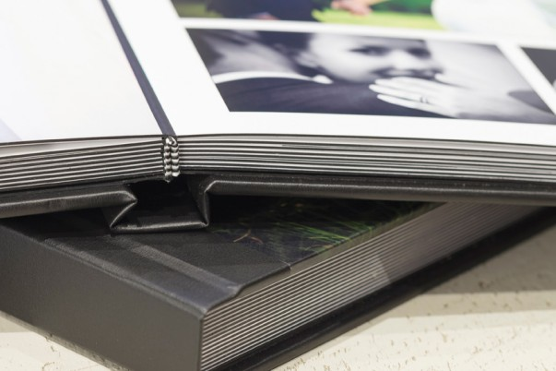
Vale Bronze Package
This package consists of:
- ~2 hrs of Photographer time to cover departure of Bride from base location, arrival at the Church/Register Office
- Images taken during the service (Church regulations permitting)
- Standard images taken immediately before, during and after the service e.g. signing the Register, posed Bride & Groom +/- family/friends
- A range of standard, posed images tailored to your requirements after the service
- Couple exiting the Church/Register Office & Married Couple leaving for the Reception
- A selection of images taken of Family alone and together with the Married Couple
- Photographs of both Family and your Guests (subject to available time) will be captured during the post ceremony session
- All images** will be made available on the website and on disc (72 dpi & copyrighted)

** Note that low resolution prints will be suitable for display online i.e. Facebook, website, email etc., but will not be of the quality required to generate larger prints. High resolution prints can generally be printed to larger sizes that include A4 and sometimes even A3 or A3+.
Larger photographs (e.g. 8” x 10” or A4) and further images on canvas or additional mounted prints can be produced at your request but will incur an additional cost.
Optional extra if you also wish a Photographer to cover the Reception /Pre-Wedding images
Optional extra – non-copyrighted, hi-resolution images provided on disc (~200dpi).
Optional extra – a PhotoBook containing up to 20 ‘prints’ or additional albums or photo wallets with 6” x 4” or 7” x 5” prints.
Optional extra – acrylic block mounted prints (single or dual)
Price: £550 plus travel expenses, if outside of Vale of Evesham / Worcestershire.
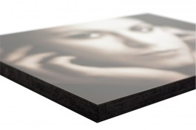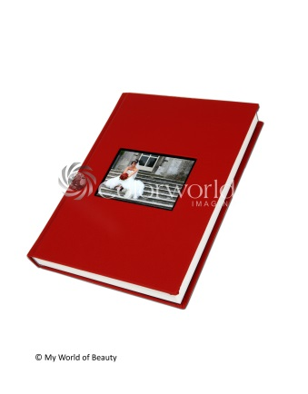
Vale Silver Package
This would also include:
- ~4 hrs of Photographer time to cover everything included in the standard Basic Bronze Package above
- Unlimited Reception coverage up to and including First Dance
- Images taken during the service (Church regulations permitting)
- Standard images taken during and after the service e.g. signing the Register
- A range of standard, posed images tailored to your requirements after the service
- Couple exiting the Church/Register Office & Married Couple leaving for the Reception
- A selection of images taken of Family alone and together with the Married Couple
- Photographs of both Family and your Guests (subject to available time) will be captured during the post ceremony session
- Images (All low res - 72 dpi & copyrighted) on disc from which you can select up to 15 for printing as 7” by 5” prints or 25 as 6 by 4” prints, mounted in a standard album
Some minimal treated images (using Adobe Photoshop) can be included in this package (at no extra cost to you) e.g. Black & White or Sepia toned photographs but the number will be limited to key images of my selection and are based on their suitability for modification / treatment.
Price: £900 plus travel expenses, if outside of Vale of Evesham / Worcestershire.
Larger photographs (e.g. 8” x 10” or A4) and further images on canvas or additional mounted prints can be produced at your request but will incur an additional cost.
Optional extra – coverage of Getting Ready / Pre-Wedding
Optional extra – add a PhotoBook of ‘prints’
Optional extra – non-copyrighted, hi-resolution images provided on disc.
Optional extra – additional albums or photo wallets with 6” x 4” or 7” x 5” prints.
Optional extra – images printed on canvas, acrylic or metal finish

Vale Gold Package
The Gold Package includes the Silver package plus
- Time to cover pre-event images (Getting Ready, Bridesmaids, Family etc), departure/arrival, during and after the service as well as Reception coverage
- Photographs taken prior to the Wedding Day (by prior arrangement only and at least 1 mth in advance) such as The Venue (Church / Register Office / Reception usually as unoccupied premises) to include both external and internal images, the local environment (relevant to the Event)
- Low resolution images on disc (copyrighted) and up to 20 unmounted prints (7” by 5”)
- One specially framed photograph of your selection (7” by 5”) or an acrylic block mounted print
- An album containing up to 20 mounted/incorporated images of your choice (Print size – 6”x4” for standard album). The album can be as a PhotoBook or as a Standard Album of mounted prints - the choice is yours
- Images modified in Photoshop i.e. specialised images (selective re-colouring, soft focus, black & white and sepia toned images, blended shots, montages and specialty photographs etc.). These can be discussed during the consultation session
- Any additional, staged photographs can be included, if required e.g. Bride and/or Groom at a specific location. It is vital that these be discussed and planned well in advance to ensure there is sufficient timing and to ensure that I capture all of your requirements
- Additional features that can be added to the Gold Package (at no extra cost, if required) including additional consultations up to the day of the Wedding, your involvement in the creation of the PhotoBook (if selected as additional) etc.
N.B. All of these preparation shots are subject to the particular Geography/Locations and Timing and can be discussed at the initial Consultation). If you have any additional or special requirements then please ensure that you mention them at our planning session(s)
Essentially, the Gold Package is a fully customised and agreed plan for the whole Event, tailored specifically to your requirements.
Price : £1250 plus travel expenses, if outside of Vale of Evesham / Worcestershire.
Larger photographs (e.g. 8” x 10” or A4) and further images on canvas or additional mounted prints can be produced at your request but will incur an additional cost.
Optional extra – images printed on canvas, acrylic or metal finish – additional cost
Optional extra – non-copyrighted, high resolution prints provided on disc – this can be substituted for the print options above.
Pricing and payment
Please note that a 10% non-refundable deposit is required at the time of Booking to reserve the Photographer’s date/time/availability with the balance to be paid at the initial pre-wedding consultation.
Note also that the pricing is only a guide to illustrate the cost of the standard packages in each case and may be subject to changes as a result of the Consultation especially if you request any optional extras.
The optional extras will be priced on an individual and as needed basis. This is because the cost may well vary based upon numbers requested, the size and composition as well as any additional materials, time or effort and potentially p&p (if applicable) required to create these for you.
I look forward to enhancing your special day and providing you with memories to keep with you.
Please note that I reserve the right to select or eliminate images where Photoshop is to be used or applied based upon their suitability for modification or enhancement.
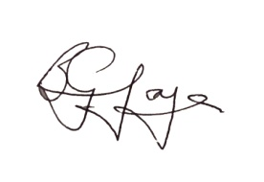
Dr Brian Joyce
Proprietor of BG Digital Weddings / BG Digital Photographs

